NATIONAL YOUTH SERVICE CORPS,
EBONYI STATE SECRETARIAT



ANALYSIS OF SAMPLE OPINION SURVEY (FORM 4B) OF
OUT GONE CORPS MEMBERS CONDUCTED IN
EBONYI STATE

2023 BATCH ‘A’ STREAM 1 SERVICE YEAR
DECEMBER, 2024.
2023 Batch ‘A’ Stream 1 (FORM 4B) Evaluation of Service Year In Ebonyi State,

Table of Contents
Introduction 3
A. DEMOGRAPHY OF THE DATA 3
1.0 STATE OF ORIGIN 3
B. PLACE OF PRIMARY ASSIGNMENT 4
1.0 LOCATION OF PLACE OF PRIMARY ASSIGNMENT 4
2. SECTOR OF PRIMARY ASSIGNMENT 5
3. PUBLIC OR PRIVATE SECTOR 6
4. IF POSTED TO PUBLIC OR PRIVATE 7
5. RELEVANCE OF PLACE OF PRIMARY ASSIGNMENT TO FIELD OF STUDY 7
6. OBJECTIONS TO THE NATURE OF PRIMARY ASSIGNMENT 8
7. SATISFACTORY CHANGE EFFECT 9
8. OPINION ABOUT THE OBJECTION BY THE END OF THE SERVICE YEAR. 9
9. REASON FOR THE CHANGE OF OPINION 10
10. TREATMENT OF CORPS MEMBERS AS STAFF DURING THE SERVICE YEAR 11
11. ATTITUDE OF PERMANENT STAFF TO CORPS MEMBERS 12
12. DEGREE OF JOB SATISFACTION FROM PRIMARY ASSIGNMENT 12
13. ACCOMMODATION BY EMPLOYERS 13
14. ALTERNATIVE ACCOMMODATION INTERPRETATION: 14
C. COMMUNITY DEVELOPMENT SERVICE 15
1. CORPS MEMBERS CDS GROUP SPECIFICATION 15
2. EFFECTIVENESS OF CDS GROUP TO THE HOST COMMUNITY 16
3. INTERACTION BETWEEN THE GROUP MEMBERS TOWARDS THE CDS PROGRAMS/PROJECT 17
4. PERSONAL CDS 17
5. HOW SUPPORTIVE WAS THE HOST COMMUNITY 18
D. SKILL ACQUISITION AND ENTREPRENEURSHIP 19
1. SKILLS ACQUISITION 19
2. SUSTAINING THE SKILLS ACQUIRED 20
3. ACCESS TO FINANCIAL SUPPORT 21
E. SERVICE OBJECTIVE 21
1. CORPS MEMBERS OPINION BEFORE MOBILISATION 22
2. CORPS MEMBERS CHANGE OF OPINION ABOUT THE SCHEME 22
SUMMARY 26
CONCLUSION 26

Introduction
A total number of five hundred (500) corps members were deployed to various places of primary assignment. 30 per cent of the population was sampled and was used to set up one hundred and fifty (150) responses. The questionnaires were self-administered to the corps members. Shown below was the analysis of the data collected.

A. DEMOGRAPHY OF THE DATA

1.0 STATE OF ORIGIN
Table A1 details the respondents’ states of origin in Nigeria, while Figure 1 provides a graphical overview of this data. From Table A1 and Figure 1, it is observed that the respondents' population is distributed as follows: 4.9 per cent are from Abia, 4.9 per cent from Akwa Ibom, 5.3 per cent from Anambra, and 0.8 per cent from Bayelsa. Additionally, 1.2 per cent are from Benue, 0.4 per cent from Borno, 9.3 per cent from Cross River, 8.5 per cent from Delta, and 8.1 per cent from Ebonyi. Furthermore, 6.5 per cent are from Edo, 1.2 per cent from Ekiti, 25.2 per cent from Enugu, 4.5 per cent from Imo, 0.4 per cent from Kaduna, 1.2 per cent from Kogi, 0.8 per cent from Lagos, 0.4 per cent from Nassarawa, 1.2 per cent from Ogun, 2.0 per cent from Ondo, 2.8 per cent from Osun, 2.4 per cent from Oyo, 0.4 per cent from Plateau, 6.9 per cent from Rivers, and 0.4 per cent from Taraba.

Table A1: Respondents’ state of origin
Variable | Frequency | Percentage (%)
Abia | 12 | 4.9
Akwa Ibom | 12 | 4.9
Anambra | 13 | 5.3
Bayelsa | 2 | 0.8
Benue | 3 | 1.2
Borno | 1 | 0.4
Cross River | 23 | 9.3
Delta | 21 | 8.5
Ebonyi | 20 | 8.1
Edo | 16 | 6.5
Ekiti | 3 | 1.2
Enugu | 62 | 25.2
Imo | 11 | 4.5
Kaduna | 1 | 0.4
Kogi | 3 | 1.2
Lagos | 2 | 0.8
Nasarawa | 1 | 0.4
Ogun | 3 | 1.2
Ondo | 5 | 2.0
Osun | 7 | 2.8
Oyo | 6 | 2.4
Plateau | 1 | 0.4
Rivers | 17 | 6.9
Taraba | 1 | 0.4
Grand Total | 246 | 100.00

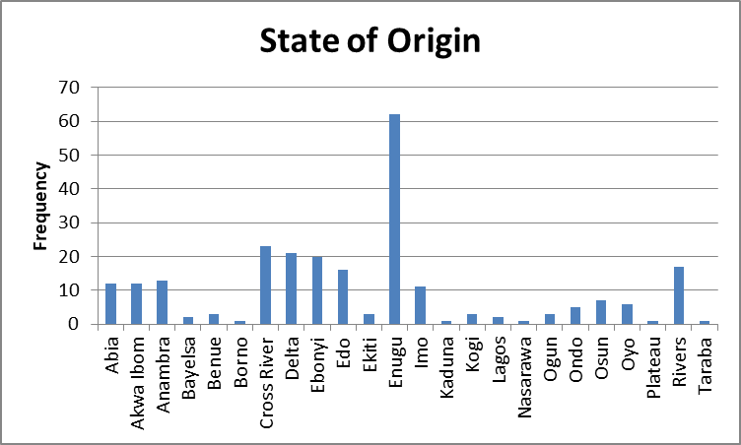
Figure 1: State of Origin

B. PLACE OF PRIMARY ASSIGNMENT
This section presents the respondents' responses on their place of Primary Assignment.

1.0 LOCATION OF PLACE OF PRIMARY ASSIGNMENT
This section presents the locations of the Primary Assignments. Table B1 shows the locations of the corps members' Primary Assignments, with a graphical representation in Figure 2. From the table, it is observed that 53.7 per cent of the corps members deployed to Ebonyi state were posted to rural areas, while 46.3 per cent were posted to urban areas.
Table B1: Corps members’ place of primary assignment
Variable | Frequency | Percentage (%)
Rural | 132 | 53.7
Urban | 114 | 46.3
Grand Total | 246 | 100

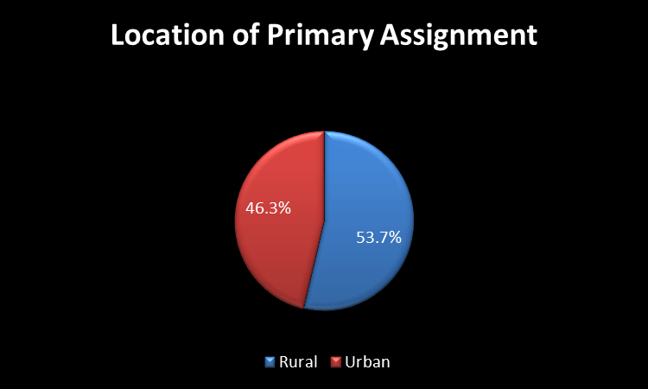
Figure 2: Location of Primary Assignment

2. SECTOR OF PRIMARY ASSIGNMENT
This section, B2, presents the sectors of the primary assignments of respondents, with a graphical representation in Figure 3. From the table, it is observed that 85.8 per cent were posted to the educational sector, 6.1 per cent to infrastructure, 7.3 per cent to health, and 0.8 per cent to agriculture.
Table B 2: Sector of primary assignment.
Sector | Frequency | Percentage (%)
Agriculture | 2 | 0.8
Education | 211 | 85.8
Health | 18 | 7.3
Infrastructure | 15 | 6.1
Grand Total | 246 | 100

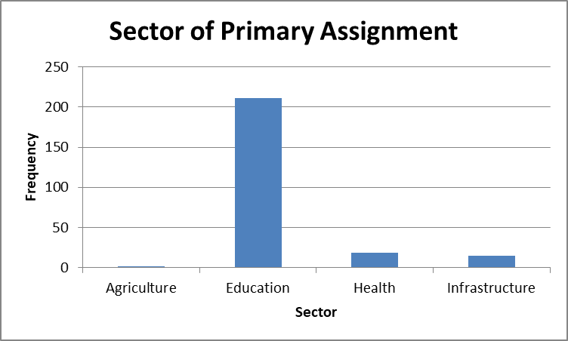
Figure 3: Sector of Primary Assignment

3. PUBLIC OR PRIVATE SECTOR
In section B3, the primary assignments of respondents are categorized by sector. Figure 4 provides a graphical representation of this data. The table indicates that 30.9 per cent of respondents were assigned to the public sector, while 69.1 per cent were assigned to private sectors.
Table B 3: Owned sector of corps members
Sector | Frequency | Percentage
Private | 170 | 69.1
Public | 76 | 30.9
Grand Total | 246 | 100

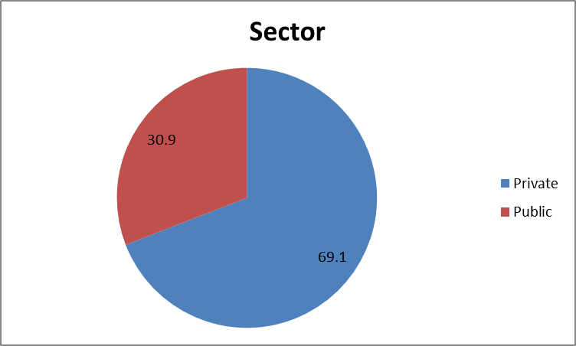
Figure 4: Owned Sector of Corps Members

4. IF POSTED TO PUBLIC OR PRIVATE
This section presents an analysis of the number of respondents assigned to various arms of the public sector. Table B4 shows that 14.6 per cent were posted to federal government-owned institutions, 41.5 per cent to state government-owned institutions, and 43.9 per cent to local government-owned institutions. A graphical representation of the data is shown in Figure 5.

Table B4: Arms in public sectors
Arms in public sector | Frequency | Percentage
Federal Owned | 36 | 14.6
Local Government Owned | 108 | 43.9
State Owned | 102 | 41.5
Total | 246 | 100

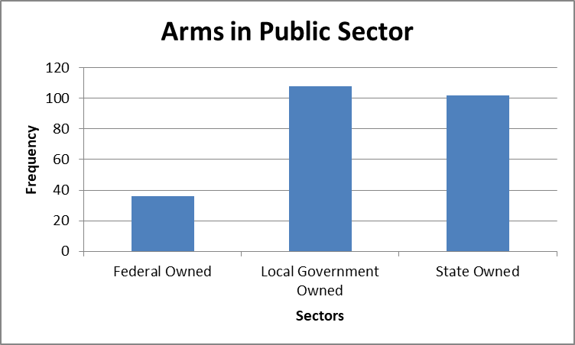
Figure 5: ARMS IN PUBLIC SECTOR

5. RELEVANCE OF PLACE OF PRIMARY ASSIGNMENT TO FIELD OF STUDY
The responses of respondents on the relevance of their Place of Primary Assignments is assess in this section. Table B5, 85.8 per cent of the corps members stated that their fields of study were relevant to their place of primary assignments and 14.2 per cent stated that their fields of study were not relevant to their place of primary assignments. A graphical representation of the data is found in Figure 6.
Table B5: Relevance of Place of Primary Assignment to Corps Members’ Field of Study
Variable | Frequency | Percentage
Not Relevant | 35 | 14.2
Relevant | 211 | 85.8
Grand Total | 246 | 100

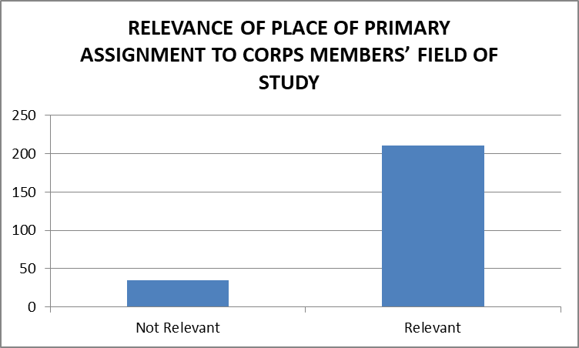
Figure 6: Relevance of Place of Primary Assignment to Corps Members’ Field of Study

6. OBJECTIONS TO THE NATURE OF PRIMARY ASSIGNMENT
This section presents the objection of the respondents to the nature of their primary assignment. From Table B6, 12.2 per cent of corps members had objections to the nature of the place of primary assignment, and 87.8 per cent of corps members had no objections. A graphical distribution of the data in represented in Figure 7.
Table B6: Objections to the nature of primary assignment.
Variable | Frequency | Percentage
No | 216 | 87.8
Yes | 30 | 12.2
Grand Total | 246 | 100

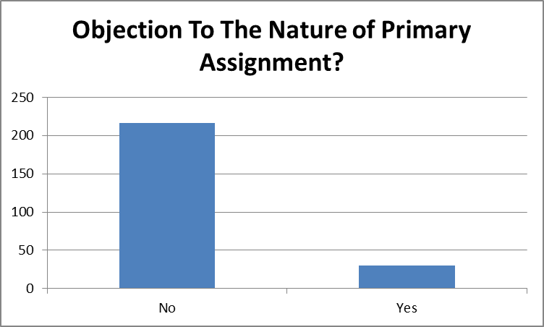
Figure 7: Objections to The Nature of Primary Assignment

7. SATISFACTORY CHANGE EFFECT
This section presents the satisfaction of the respondents on the change effect in their PPA. Table B7 gives a value count of their response while Figure 8 provides a graphical overview of the information. The analysis showed that 79.3 per cent of corps members were satisfied with the change affected, and 20.7 per cent were not satisfied.

Table B7: Satisfactory Change Effect.
Variable | Frequency | Percentage
No | 51 | 20.7
Yes | 195 | 79.3
Grand Total | 246 | 100.00

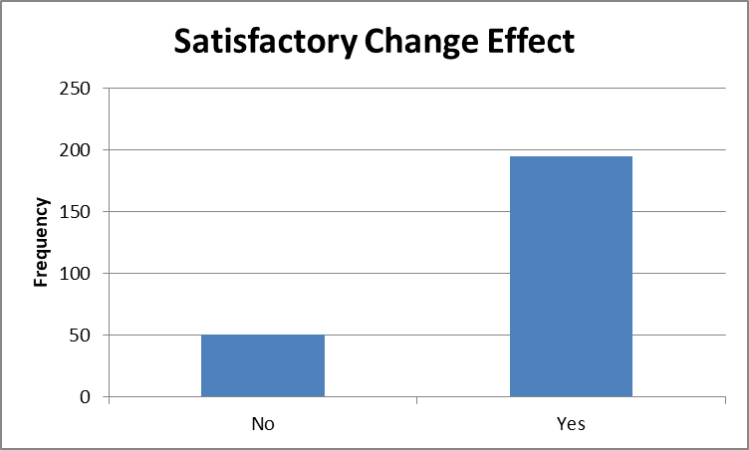
Figure 8: Satisfactory Change Effect.

8. OPINION ABOUT THE OBJECTION BY THE END OF THE SERVICE YEAR.
This section presents the change in respondents' opinions on their objection by the end of the service year. Table B8 shows the frequency and percentages of their responses, while Figure 9 provides a graphical overview. From the above analysis, 30.1 per cent of corps members changed their opinion at the end of service year and 69.9 per cent did not.

Table B8: Opinion about the Objection by the End of the Service Year.
Variable | Frequency | Percentage
No | 172 | 69.9
Yes | 74 | 30.1
Grand Total | 246 | 100.0

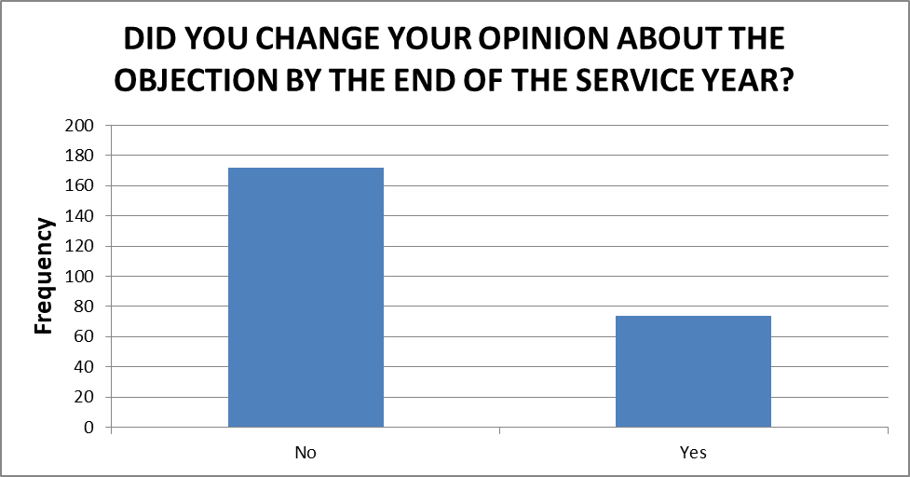
Figure 9: Opinion about the Objection by the End of the Service Year.

9. REASON FOR THE CHANGE OF OPINION
This section presents the Corps members' reasons for their change of opinion about the objection by the end of the service year. Table B9 presents a tabular representation of their response, a graphical information of the data is presented in Figure 10. The data reveals that among those who changed their opinion about their initial objections to the nature of their Primary Place of Assignment, 22.4 per cent cited the attitude of their employers or HODs, 43.9 per cent found the assignment interesting, 16.3 per cent credited their own resourcefulness during the service year, the attitude of their colleagues influenced 6.1 per cent, and 11.4 per cent had other reasons.

Table B9: Reason for the Change of Opinion
Variable | Frequency | Percentage
Attitude of Colleagues | 15 | 6.1
Attitude of Employer/Head Of Department | 55 | 22.4
Interesting Nature of Assignment | 108 | 43.9
My Own Resourcefulness | 40 | 16.3
Others | 28 | 11.4
Total | 246 | 100

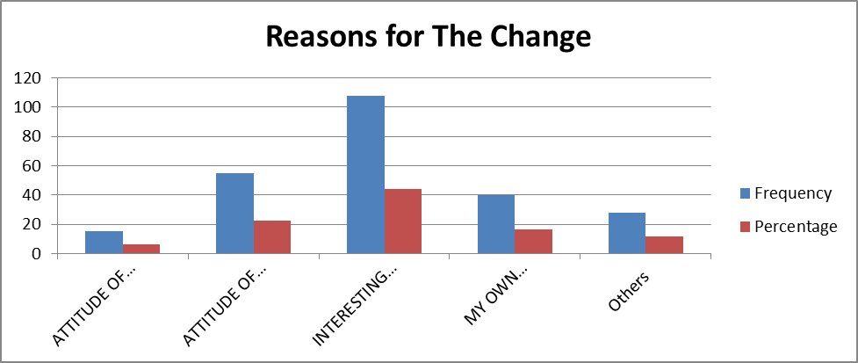
Figure 10: Reason for the Change of Opinion

10. TREATMENT OF CORPS MEMBERS AS STAFF DURING THE SERVICE YEAR
This section presents responses on how the Corps Members were treated either as permanent staffs or not. Table B10 shows the responses of the respondents in terms of Frequency and percentage while Figure 11 gives a graphical representation of their responses. From Table B10, it is observed that 67.1 per cent of corps members said they were treated as permanent staff and 32.9 per cent stated otherwise.

Table B10: Treatment of corps members as staff during the service year
Treated like a permanent Staff? | Frequency | Percentage
No | 81 | 32.9
Yes | 165 | 67.1
Grand Total | 246 | 100

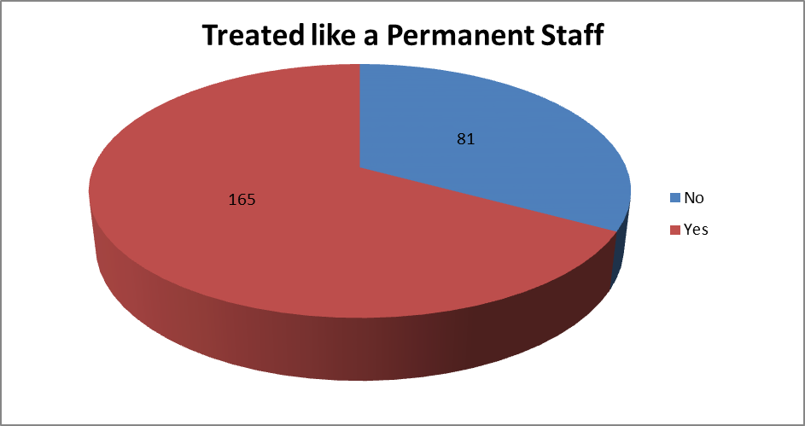
Figure 11: Treatment of corps members as staff during the service year

11. ATTITUDE OF PERMANENT STAFF TO CORPS MEMBERS
The attitude of Permanent staffs to Corps Members is presented in this section. Table B11 gives the tabular representation of the respondents while Figure 12 shows the graphical representation of their responses. Results obtained showed that, 51.2 per cent of the Corps members stated that there was a cordial attitude between them (corps members) the permanent staff, 5.7 per cent stated that there was an unfriendly attitude between them (corps members) and the permanent staff and 43.1 per cent agreed that there was a very cordial attitude between them (corps members) and the permanent staff.
Table B11: Attitude of permanent staff to corps members
Attitude of the permanent staff to corps members | Frequency | Percentage
Cordial | 126 | 51.2
Unfriendly | 14 | 5.7
Very Cordial | 106 | 43.1
Grand Total | 246 | 100

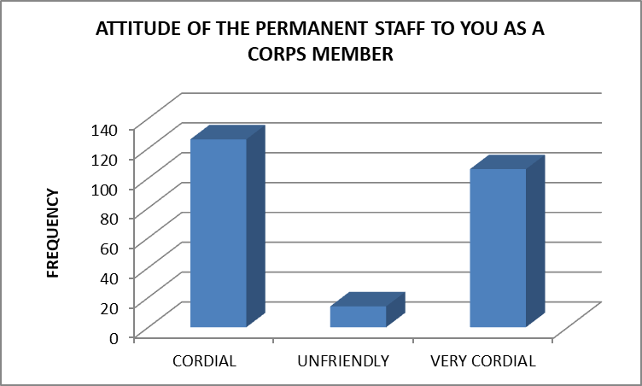
Figure 12: Attitude of permanent staff to corps members

12. DEGREE OF JOB SATISFACTION FROM PRIMARY ASSIGNMENT
The degree to which the Corps member felt satisfied with their place of primary assignment is evaluated in this section. Table B12 gives a tabular representation of their responses with 57.3 per cent had high job satisfaction, 17.5 per cent had low job satisfaction and 25.2 per cent had a very high job satisfaction from the place of primary assignment. Figure 13 shows a graphical representation of their responses.

Table B12: Degree of job satisfaction from primary assignment
Degree of job satisfaction from primary assignment | Frequency | Percentage
High | 141 | 57.3
Low | 43 | 17.5
Very High | 62 | 25.2
Grand Total | 246 | 100.00

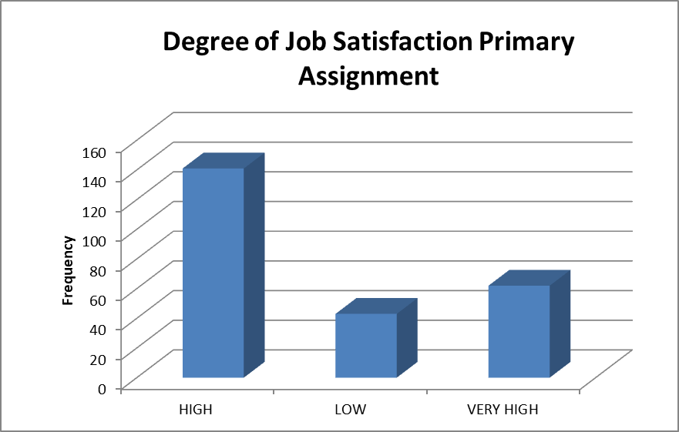
Figure 13:Degree of job satisfaction from primary assignment

13. ACCOMMODATION BY EMPLOYERS
Corps members responses to accommodation by employers is represented in Table B13 and Figure 14. The analysis showed that 54.9 per cent of corps members were not accommodated by their employers and 45.1 per cent of corps members were accommodated by their employers.

Table B13: Accommodation by employers
Accommodation by your employer | Frequency | Percentage
No | 135 | 54.9
Yes | 111 | 45.1
Grand Total | 246 | 100.00

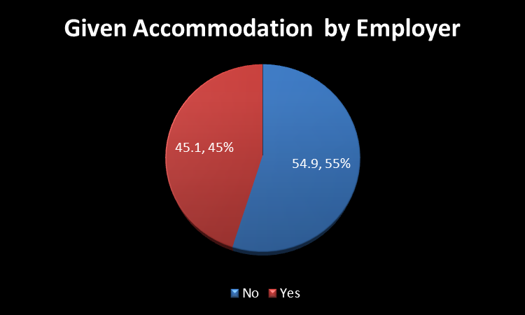
Figure 14: Accommodation by employers

14. ALTERNATIVE ACCOMMODATION INTERPRETATION:
Analysis of the alternative accommodations gotten by the corps members for those their employers did not provide accommodation is presented in Table B14 and Figure 15. Findings from their responses shows that, 35.8 per cent stayed at corps members’ lodges, 43.5 per cent of corps members rented accommodation, 10.1 per cent stayed at MCAN, NACC and NCCF lodges and 10.6 per cent stayed with relatives/friends.
Table B14: Alternative accommodation options
Alternative accommodation | Frequency | Percentage
Corpers' Lodge | 88 | 35.8
Rented Accommodation | 107 | 43.5
Stayed In Mcan/Nccf/Nacc Lodge | 25 | 10.1
Stayed With A Relation/Friend | 26 | 10.6
Grand total | 246 | 100

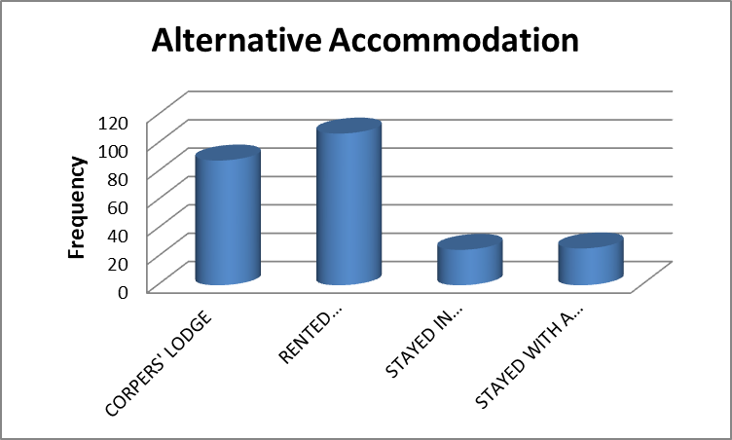
Figure 15: Alternative accommodation options

C. COMMUNITY DEVELOPMENT SERVICE

1. CORPS MEMBERS CDS GROUP SPECIFICATION
The various CDS groups the corps members belonged to is analysed in this section. Table C1 gives a tabular representation of the data with their value counts and percentages. Findings of the results showed that, 2.4 per cent of the corps members belonged to Agro allied, 0.4 belonged to Corps Legal Aid Group (CLAG), 4.1 per cent belonged to Cultural and Tourism Group. Also, 2.8 per cent belonged to Drug free and Quality Control Group (NDLEA, NAFDAC, SON), with 3.7 per cent belonging to Editorial/Publicity Group. Furthermore, 27.2 per cent belonged to Environmental and protection and Sanitation Group (Eco-vanguard, NESREA), 11 per cent belonged to Medical and Health Services Group (Red Cross, Breast without Spot, Polio Plus, etc.), 37.8 per cent belonged to Others, 4.1 per cent belonged to Road Safety Group, 6.5 per cent belonged to Sport Group. A graphical representation of the data is shown in Figure 16.

Table C 1: Corps members CDS groups specification.
Corps members CDs group specification | Frequency | Percentage (%)
Agro-Allied Group | 6 | 2.4
Corps Legal Aid Group(CLAG) | 1 | 0.4
Cultural and Tourism Group | 10 | 4.1
Drug free and Quality Control Group(NDLEA, NAFDAC, SON) | 7 | 2.8
Editorail/Publicity Group | 9 | 3.7
Environmental and protection and Sanitation Group(Ecovanguard, NESREA) | 67 | 27.2
Medical and Health Services Group(Red Cross, Breast without Spot, Polio Plus, e.t.c) | 27 | 11.0
Others | 93 | 37.8
Road Safety Group | 10 | 4.1
Sport Group | 16 | 6.5
Total | 246 | 100.00

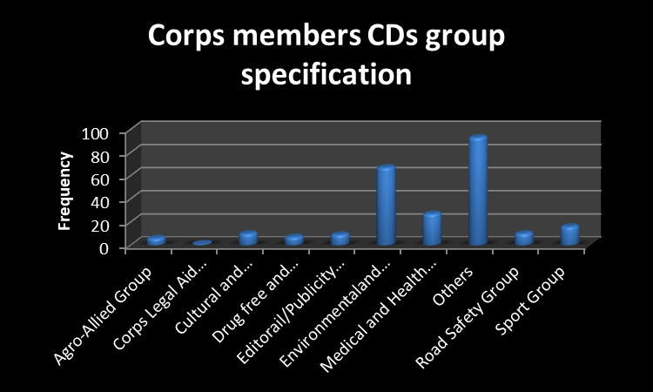
Figure 16: Corps members CDS groups specification.

2. EFFECTIVENESS OF CDS GROUP TO THE HOST COMMUNITY
Corps members' responses on the effectiveness of CDS on their host community is presented in this section. Table C2 depicts the rate of effectiveness of CDS Group to the host community. While 64.6 per cent believed the groups are VERY EFFECTIVE in the host community, 3.3 per cent believed they were NOT EFFECTIVE while 32.1 per cent believed that they are just EFFECTIVE. Graphical representation of Table C16 is seen in Figure 17.
Table C2: Effectiveness of CDS group to the host community
Effectiveness of CDs group to the host community | Frequency | Percentage
Effective | 79 | 32.1
Not Effective | 8 | 3.3
Very Effective | 159 | 64.6
Grand Total | 246 | 100

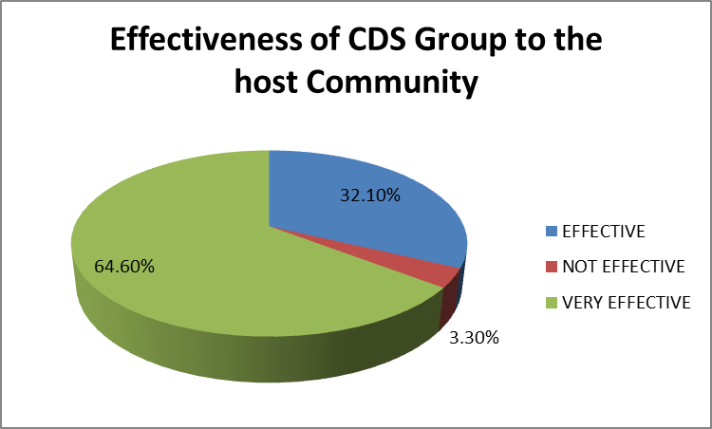
Figure 17: Effectiveness of CDS group to the host community

3. INTERACTION BETWEEN THE GROUP MEMBERS TOWARDS THE CDS PROGRAMS/PROJECT
The level of interaction between the group members regarding the CDS programs/project is presented in this section. The analysis of their responses showed that 42.3 per cent indicated a cordial interaction, 55.7 per cent responded that there was a very cordial interaction between the group, while only 2 per cent said there was no cordial interaction between them. Table C3 gives a tabular representation of the data while Figure 18 gives a graphical representation of the data.
Table C3: Interaction between the group members towards the CDS programs/project
Interaction between the group members towards the CDs programs/project | Frequency | Percentage
Cordial | 104 | 42.3
Not Cordial | 5 | 2.0
Very Cordial | 137 | 55.7
Grand Total | 246 | 100

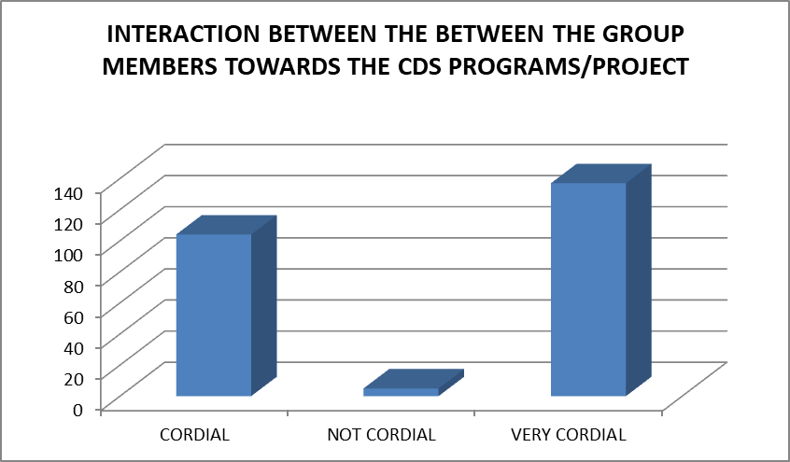
Figure 18: Interaction between the group members towards the CDS programs/project

4. PERSONAL CDS
This section shows the number of corps members who embarked on any personal CDS. Results showed that 19.5 per cent of corps members embarked on personal CDS projects and 80.5 per cent did not embark on any personal CDS projects. Table C4 and Figure 19 shows the responses on the respondents.
Table C4: Corps members who undertook personal CDS
PERSONAL CDS PROJECT | Frequency | Percentage
No | 198 | 80.5
Yes | 48 | 19.5
Grand Total | 246 | 100.0

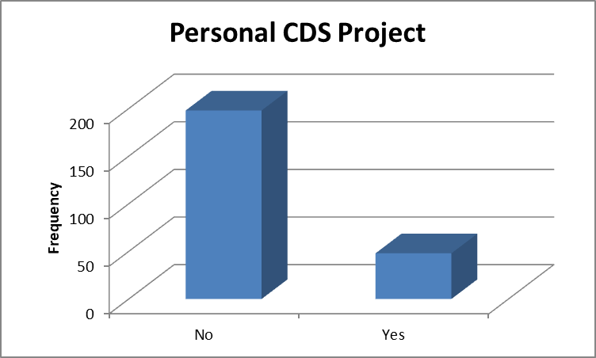
Figure 19: Corps members who undertook personal CDS

5. HOW SUPPORTIVE WAS THE HOST COMMUNITY
This section analyse the responses of respondents on the level of support host communities gave Corps members. Results of their responses showed that 59.8 per cent of the corps members said their host communities were supportive, 21.1 per cent of the corps members said their host communities were indifferent and 19.1 per cent of the host communities were not supportive.
Table C5 gave a tabular representation of the percentages and frequencies of their responses while Figure 19 shows a graphical representation of the data.
Table C5: How supportive was the host community
Variable | Frequency | Percentage
Indifferent | 52 | 21.1
Not Supportive | 47 | 19.1
Supportive | 147 | 59.8
Grand Total | 246 | 100

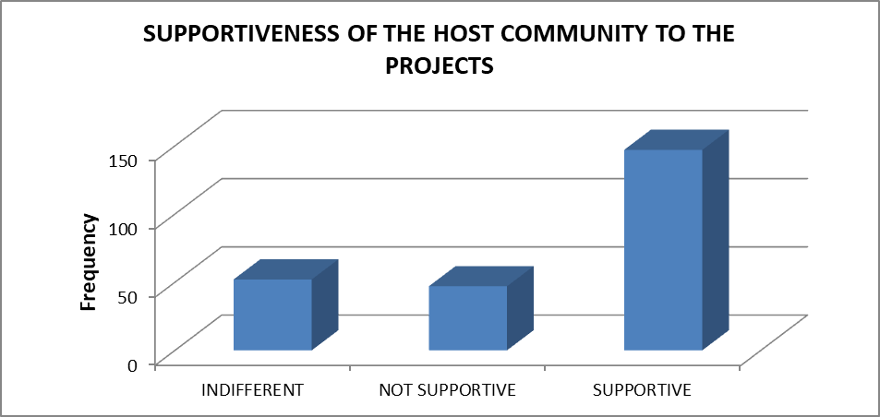
Figure 20: How supportive was the host community

D. SKILL ACQUISITION AND ENTREPRENEURSHIP
This section presents the responses on questions relating to skills acquisition and entrepreneurship programs they undertook during their service year.

1. SKILLS ACQUISITION
The analysis of various skills acquired during their service year is presented in this section. Results of findings highlights the following, 7.3 per cent of the corps members acquired Agro-Allied skills, 9.3 per cent of the corps members acquired Beautification Skills, 2.8 per cent of the corps members acquired Construction skills. Furthermore, 4.9 per cent of the corps members acquired Cosmetology skills, 2.0 per cent of the Corps members acquired Culture and Tourism skills, 14.2 per cent of the corps member Education skills, 4.1 per cent of the corps members acquired Environment Skills. Further results showed that 4.9 per cent of the corps members acquired Film & Photography Skills, 7.3 per cent of the corps members acquired Food Processing Skills, 10.2 per cent of the corps members acquired ICT skill, 28.0 per cent of the corps members acquired Others skill and 2.8 per cent of the corps members acquired Power & Energy skills. A tabular representation of this data is presented in Table D1 and Figure 20.
Table D1: Skills Acquired during Service Year
Skills Acquisition | Frequency | Percentage (%)
Agro Allied | 18 | 7.3
Automobile | 5 | 2.0
Beautification | 23 | 9.3
Contruction | 7 | 2.8
Cosmetology | 12 | 4.9
Culture and Tourism | 5 | 2.0
Education | 35 | 14.2
Enviroment | 10 | 4.1
Film & Photography | 12 | 4.9
Food Processing | 18 | 7.3
ICT | 25 | 10.2
Others | 69 | 28.0
Power & Energy | 7 | 2.8
Total | 246 | 100

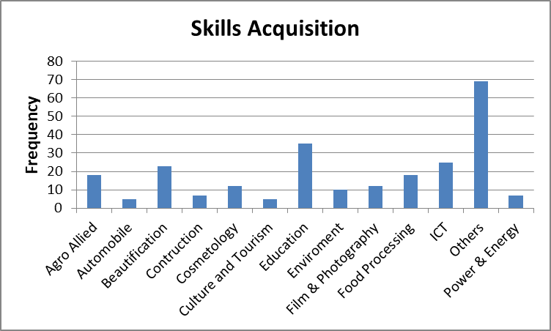
Figure 21: Skills Acquired during Service Year

2. SUSTAINING THE SKILLS ACQUIRED
The responses on the sustainability of the acquired skills by Corps members is discuss in this section. Results showed that 12.2 percent indicated that they will not sustain the skills acquired while 87.8 percent corps members indicated that they will sustain the skill acquired. Tabular and graphical representation of their responses is presented in Table D2 and Figure 22 respectively.

Table D2: Sustaining the skills acquired
SUSTAINING THE SKILLS ACQUIRED | Frequency | Percentage
No | 30 | 12.2
Yes | 216 | 87.8
Grand Total | 246 | 100.00

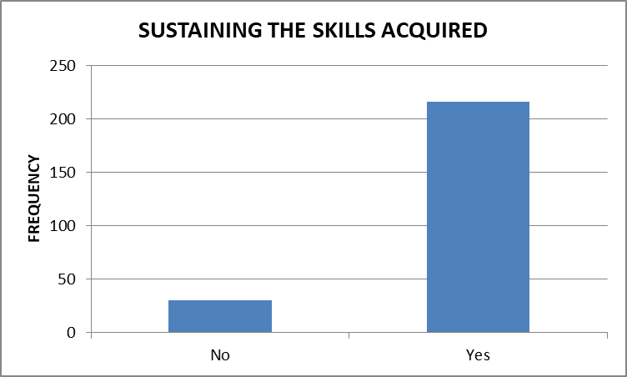
Figure 22: Sustaining the skills acquired

3. ACCESS TO FINANCIAL SUPPORT
The access to financial support during the service year is presented in this section. Findings from their responses indicates that 91.1 percent indicated to have not received financial support while 8.9 indicated to have access to financial support. Table D3 gives a tabular representation of their responses while a graphical representation of their responses is seen in Figure 23.
Table D3: Access to financial support
Access to Financial Support | Frequency | Percentage
No | 224 | 91.1
Yes | 22 | 8.9
Grand Total | 246 | 100

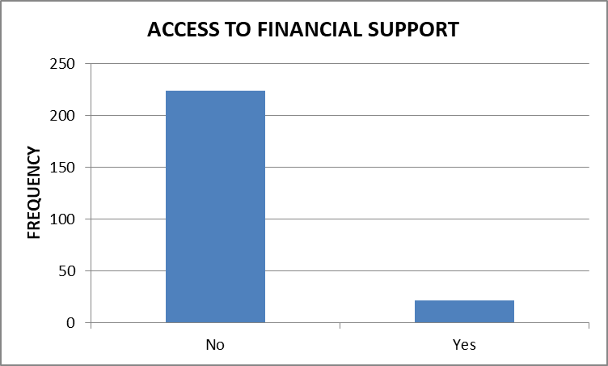
Figure 23: Access to financial support

E. SERVICE OBJECTIVE
This section evaluates the opinions of corps members on the objectives of the NYSC scheme.

1. CORPS MEMBERS OPINION BEFORE MOBILISATION
This section presents the opinion of the respondents regarding the NYSC scheme before mobilization for national service. From the results, 225 constituting 91.5 percent of the respondents indicated the scheme is relevant to nation building while only 21 respondents amounting to 8.5 percent of the total population. Results of findings are shown in Table E1 and Figure 23

Table E1: Corps members’ opinion before mobilisation
Corps members opinion before mobilisation | Frequency | Percentage (%)
Relevant to nation building | 225 | 91.5
Not relevant to nation building | 21 | 8.5
Grand Total | 246 | 100.0

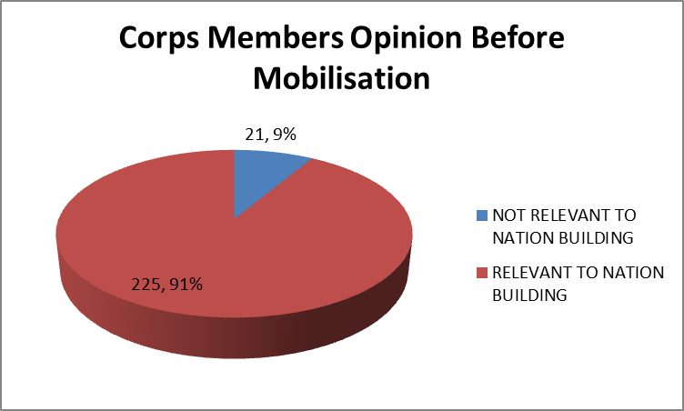
Figure 24: Corps members’ opinion before mobilisation

2. CORPS MEMBERS CHANGE OF OPINION ABOUT THE SCHEME
This section assess the change of opinion as touching the NYSC scheme towards nation building. Results of findings showed that 61.4 percent did not change their opinion indicating that the NYSC scheme is relevant to the national building while 38.6 respondents of the respondents changed their opinion about the scheme after participating in the scheme. A tabular representation of their responses is seen in Table E2 and Figure 25 gives a graphical view of the data.
Table E2: Corps members change of opinion about the scheme
Corps members change of opinion about the scheme | Frequency | Percentage (%)
No | 151 | 61.4
Yes | 95 | 38.6
Grand Total | 246 | 100.0

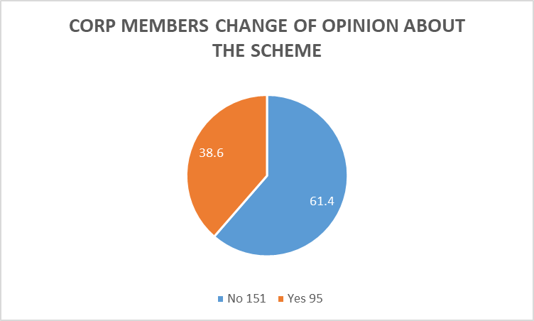
Figure 25: Corps members change of opinion about the scheme
3. NYSC OBJECTIVES ON DISCIPLINE AMONG CORPS MEMBERS
The respondents' responses on objectives of the scheme such as discipline, patriotism, adaptability, team spirit, integration, national growth, self-reliance, and national unity are evaluated in this section. Table E3 gives the value counts on each of the objective with their frequencies.

Table E3: Ratings on NYSC Objectives
Variables | Very Effective |  | Effective |  | Ineffective |  | Very Ineffective
 | Frequency | Percentage (%) | Frequency | Percentage (%) | Frequency | Percentage (%) | Frequency | Percentage (%)
Discipline Among Corp Members | 135 | 54.9 | 100 | 40.7 | 8 | 3.3 | 3 | 1.2
Patriotism | 105 | 42.7 | 124 | 50.4 | 14 | 5.7 | 3 | 1.2
Adaptability | 103 | 41.9 | 128 | 52.0 | 11 | 4.5 | 3 | 1.2
Team Spirit | 135 | 54.9 | 103 | 41.9 | 5 | 2.0 | 3 | 1.2
Integration | 101 | 41.1 | 134 | 54.5 | 10 | 4.1 | 1 | 0.4
National Growth | 123 | 50.0 | 101 | 41.1 | 18 | 7.3 | 4 | 1.6
Self-Reliance | 146 | 59.3 | 94 | 38.2 | 4 | 1.6 | 2 | 0.8
National Unity | 134 | 54.5 | 91 | 37.0 | 14 | 5.7 | 7 | 2.8
`
The analysis of the effectiveness of NYSC objectives among corps members during the service year reveals several key insights. A significant majority, 54.9 per cent, rated discipline as very effective, while 40.7 per cent found it effective. In contrast, 3.3 per cent viewed discipline as ineffective, and 1.2 per cent considered it very ineffective.
Regarding patriotism, 42.7 per cent of corps members indicated it was very effective, and 50.4 per cent found it effective. However, 5.7 per cent felt it was ineffective, and 1.2 per cent deemed it very ineffective.
Adaptability was rated very effective by 41.9 per cent of respondents and effective by 52 per cent. A smaller proportion, 4.5 per cent, considered it ineffective, while 1.2 per cent found it very ineffective.
When assessing team spirit, 54.9 per cent of corps members believed it was very effective, and 41.9 per cent rated it as effective. Only 2 per cent viewed team spirit as ineffective, and 1.2 per cent found it very ineffective.
Integration among corps members was seen as very effective by 41.1 per cent and effective by 54.5 per cent. Meanwhile, 4.1 per cent considered it ineffective, and 0.4 per cent rated it very ineffective.
National growth was perceived as very effective by 50 per cent of respondents, with 41.1 per cent finding it effective. However, 7.3 per cent viewed it as ineffective, and 1.6 per cent deemed it very ineffective.
Self-reliance was highly regarded, with 59.3 per cent of corps members indicating it was very effective and 38.2 per cent finding it effective. A small fraction, 1.6 per cent, considered it ineffective, and 0.8 per cent rated it very ineffective.
Finally, national unity was rated very effective by 54.5 per cent of respondents and effective by 37 per cent. However, 5.7 per cent found it ineffective, and 2.8 per cent deemed it very ineffective. These findings suggest that most corps members perceive the NYSC objectives as effective or very effective across various dimensions. Nonetheless, a small percentage of respondents found these objectives to be ineffective or very ineffective, indicating areas that may require further improvement.
4. WILLINGNESS TO STAY BACK IN STATE OF DEPLOYMENT
The willingness of Corps members to stay back in the state of deployment is assess in this section. Findings showed that 69.9 per cent indicated they are not going to stay back in the state of deployment while 30.1 per cent indicated they would stay back in the state of deployment. Table E4 gives a tabular representation of findins while a graphical overview is represented in Figure 26.

Table E4: Willingness to stay back in state of deployment
Willingness to stay back in state of deployment | Frequency | Percentage (%)
No | 172 | 69.9
Yes | 74 | 30.1
Grand Total | 246 | 100

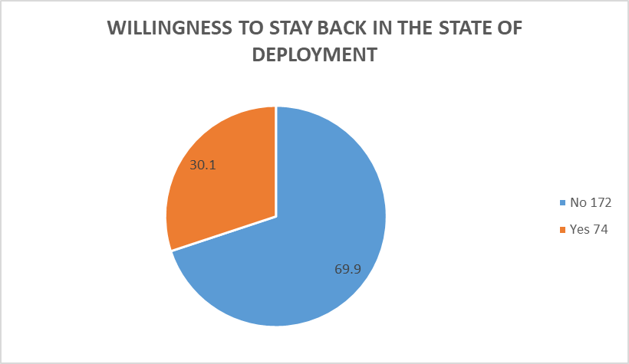
Figure 26: Willingness to stay back in state of deployment
5. WILLINGNESS TO REMAIN IN THE STATE WHEN RETAINED BY THE EMPLOYER
This section present corps members’ willingness to remain in the state of deployment when retained by the employer. From the analysis above, 64.7 per cent indicated not staying back in the state of deployment if retained by the employer, while 35.3 per cent indicated staying back in the state of deployment if retained by the employer. A tabular overview is seen in Table E5 while Figure 27 gives a graphical distribution of the findings.
TABLE E5: WILLINGNESS TO REMAIN IN THE STATE WHEN RETAINED BY THE EMPLOYER
Table E5: Willingness to remain in the state when retained by employer
Willingness to remain in the state when retained by the employer | Frequency | Percentage (%)
No | 170 | 69.1
Yes | 76 | 30.9
Grand Total | 246 | 100

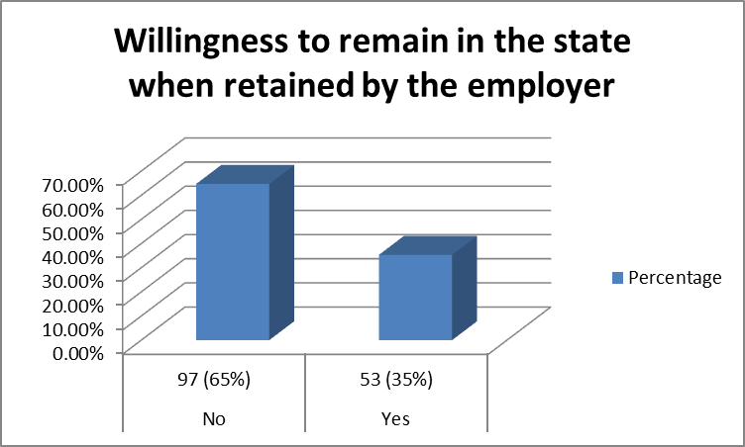
Figure 27: Willingness to remain in the state when retained by employer

SUMMARY
The following findings were obtained from the opinion survey:
- Demography Data: The survey included 500 corps members, with a sample size of 150. The respondents’ states of origin are detailed, showing a diverse distribution across Nigerian states with the highest representation from Enugu at 25.2 per cent .
- Primary Assignment Locations: Over half of the corps members were posted to rural areas (53.7 per cent), while the rest were in urban settings.
- Sectors of Assignment: A vast majority were assigned to the educational sector, followed by health, infrastructure, and agriculture.
- Public vs. Private Sector: About 70% were assigned to private sectors, with the rest in public sectors, including federal, state, and local government institutions.
- Relevance to Field of Study: Most corps members found their assignments relevant to their fields of study.
- Objections and Satisfaction: A small percentage had objections to their assignments, but most were satisfied with the changes affected during their service.
- Opinion Change: By the end of the service year, some corps members changed their initial objections, citing various reasons like employer attitude and the interesting nature of the assignment.
- Treatment as Staff: Two-thirds felt they were treated as permanent staff during their service year.
- Accommodation: Over half (54 per cent) of the corps members indicated they were not accommodated by their employers.
- Community Development Service (CDS): Corps members participated in various CDS groups, with most finding their activities very effective in the host community.
- Skill Acquisition: Corps members acquired diverse skills during their service year, with a high percentage planning to sustain these skills.
- Financial Support: A small number received financial support during their service year.
- Service Objective: The majority viewed the NYSC scheme as relevant to nation-building before and after mobilization, with high ratings for discipline, patriotism, adaptability, and other objectives.
- Post-Service Plans: Most corps members were not willing to stay in their state of deployment after service, even if retained by their employer.

CONCLUSION
Based on the comprehensive findings of the opinion survey, it is evident that the National Youth Service Corps (NYSC) scheme plays a pivotal role in fostering national unity, skill acquisition, and professional development among Nigerian youth. The diverse representation of corps members from various states, significant postings to rural areas, and predominant assignments in the educational sector underscore the scheme's commitment to bridging educational gaps and enhancing rural development. Despite the majority being placed in the private sector, the relevance of their assignments to their fields of study and the general satisfaction expressed highlight the program's alignment with career development goals. The adaptability and patriotism cultivated through the NYSC are further reflected in the positive shift in opinions over the service year and the effective participation in Community Development Service (CDS) activities. The acquisition of diverse skills and the intent to sustain them post-service illustrate the scheme's impact on long-term personal and professional growth. However, the challenges of inadequate accommodation and financial support point to areas requiring improvement to enhance the overall experience of corps members. The reluctance of most corps members to remain in their state of deployment post-service, despite the scheme’s objectives of nation-building and integration, suggests a need for addressing underlying issues such as local economic opportunities and living conditions.
In conclusion, the NYSC scheme remains a cornerstone of national development, fostering discipline, patriotism, and adaptability among Nigerian youth. By addressing the highlighted challenges, the scheme can further solidify its relevance and effectiveness in achieving its foundational goals of unity and national progress.

